News Release

AirSept Granted Patent for its GM Retrofit Cabin Air Filter
Provides an OE-fit that installs within the vehicle A/C system to help eliminate pollen, other microorganisms and contaminants

Atlanta – May 15, 2019 – AirSept, the industry leader in the development of OEM and aftermarket solutions for complex automotive repair problems, has been granted a patent for its OEM-approved GM Retrofit Cabin Air Filter. The new patent raises AirSept’s portfolio to more than 30 issued patents.

According to AirSept president Aaron Becker, GM built over 5 million full-size pickup trucks and SUVs from 2007 to 2014 with a cavity for cabin air filters (CAFs), but with no factory-equipped CAF installed.

“As a result, it is impossible to access the underdash cavity without bending the filter around the transmission bellhousing. Unfortunately, bending a traditional CAF cracks and tears its frame, allowing ingress of pollen, bacteria, dirt, soot and other airborne contaminants and rendering the filter ineffective,” explained Becker.

AirSept’s GM Retrofit Cabin Air Filter features a segmented frame that bends to go around obstacles, then straightens as the technician inserts it in the CAF opening. The product can be installed in about 15 minutes or less following AirSept’s four-step installation process that requires no special tools. Installing the retrofit filter greatly reduces in-cabin dust and pollutants and extends blower motor service life. Standard and extra odor protection carbon filter versions are available.

“We are pleased that our patent has been granted for this handy retrofit filter that helps promote clean air within the vehicle,” said Becker. “Our product provides repair shops with a beneficial business opportunity.”

For more information about the AirSept GM Retrofit Cabin Air Filter, visit www.AirSept.com.

# # # #

Image Attached: 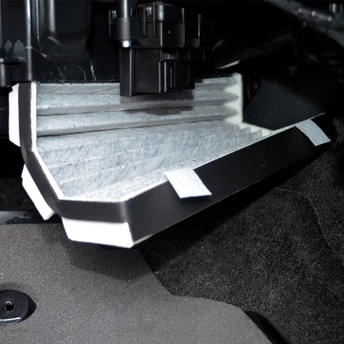

About AirSept
In 1989 AirSept created the first long-lasting solution to the problem of unwanted mold and mildew odor in automobile air conditioning systems. The product quickly became popular and in 1991 AirSept was incorporated as a company. AirSept began partnering with global OEMs and suppliers to not only market its Cooling Coil Coating, but to also develop other unique, new problem-solving products. From those humble beginnings, AirSept has grown to be the industry leader in the development of OEM and aftermarket solutions to complex automotive repair problems. AirSept products are designed to save time, money and labor. For more information, visit www.AirSept.com.

For further product information, contact:
Aaron Becker, President
AirSept
678-973-2287
abecker@airsept.com

For further PR information, contact:
Gary McCoy, President
Fairway Communications
847-372-0722
gmccoy@fairwaycommunications.com

Leslie Allen
Owner
Wildcat Communications
615-429-7965
leslieallen.wildcat@gmail.com

